**Design analysis**

**Final design of linear launcher:**

The Design for this project is final so far. Due to CoVid-19 Lockdown, it may be changed during fabrication after the reopening of Universities and Markets.

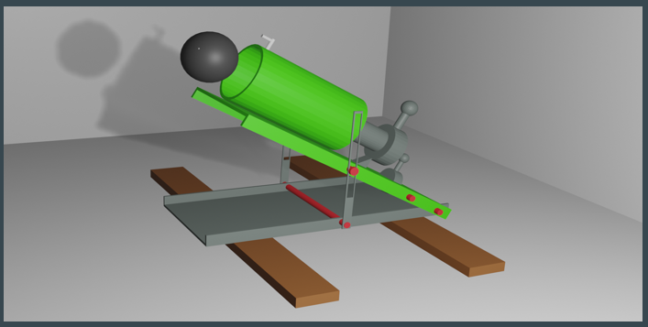

**1. Structural analysis:**

Line launcher consists of following parts:

* Base plate
* Movable plate
* Main pipe
* Link
* Striking rod
* Spring
* Holder
* Trigger
* **Base plate and movable plate:**

Base plate and movable are made up of steel sheet thickness of 1mm approx. Movable plate is joined with base plate in such a way that the movable plate will able to move along one specific axis. The base plate is bearing all weight and is supporting moveable plate over it.

* **Main pipe:**

The main pipe is made up of hard plastic. The pipe is attached at the top of movable plate. So, this will help in moving main pipe and movable plate together.

* **Striking rod and spring assembly:**

Striking rod is also made up of hard plastic. It is placed inside the main pipe with spring attached to it. This all works on the energy stored in the spring. More the stiffness of the spring, more will be the energy stored.

* **Trigger:**

The trigger is made of the plastic or metal. It connects with the moveable plate and its one end is present at the empty slot present in the center of the moveable plate which serves as the lock. While the other end is act as trigger.

* **Link:**

The link is also made of the plastic or metal. It is the connection between the base plate and the moveable plate. It serves as the angle changer between the two plates due to which the angle of projection also changes. Link is joined with base plate as well as movable plate with the help of axis rod.

* **Holder:**

Holder holds the striking rod. This will help in projecting the ballon the choice of the performer of experiment. Holder holds the trigger and striking rod so that the rod will not release its energy at any instant, but it will push the ball when required with the help of trigger.

**2. System analysis:**

In system analysis, the working elements like range, angle and height and on what factor range, angle and height of our device depends. And on changing these, what is the effect on the properties of device.

* **Relation between angle and range:**

Range and angle are related directly related according to the formula:

**R = $\frac{v_{i}^{2}sin(2θ)}{g}$**

This shows that when the angle increases, range also increases but this happen to a certain limit. Maximum range of launcher occurs at angle of 45 degrees. After 45 degrees the range starts decreasing.

* **Relation between angle and height:**

Height and angle are also directly related according to the formula:

**H = $\frac{v_{i}^{2}\sin^{2}{θ}}{2g}$**

This shows that as angle increases the height also increases but to a certain limit of 90 degrees. Maximum height occurs at an angle of 90 degrees.

* **Relation between range and velocity:**

Range is directly proportional to the velocity. As velocity increases range of our device also increases and velocity of our device depends upon stiffness of the spring. Stiffer the spring more energy it stores so more will be the velocity. Formula for range is:

**R = $\frac{v_{i}^{2}sin(2θ)}{g}$**

**3. Working analysis of device:**

Following are the steps that describe the working of our device:

* Movable plate allows to move along only one axis.
* This device works on law of conservation of energy.
* First, we mechanically store energy in the spring.
* This can be done by compressing the spring.
* Once the spring is fully compressed, then it is ready to transfer its energy to the ball.
* This can be done by relaxing the spring with the help of trigger.
* It will relax the striking rod and ball is pushed.
* Velocity of the striking rod depends upon the stiffness of the spring.
* Stiffer the spring, more will be the energy stored and more will be the energy given to the ball so larger will be its velocity.
* Measurement of angle can be done with the help of a protector.
* Closer the angle to 45 degrees, larger will be the range.